EMBARGOED UNTL 9PM FRIDAY 14 SEPTEMBER
14 September 2018
Winners announced in 2018 WiT Awards
Two women from opposite ends of the technology spectrum have been named Queensland’s most outstanding achievers at the 2018 Women in Technology Awards in Brisbane tonight. (Friday 14 Sept)

The ICT Outstanding Award went to Sandra Slater, acting Chief Information Officer for the Department of Transport and Main Roads. A career public servant, Sandra leads one of the biggest IT teams in Queensland government with more than 400 technical staff and contractors. She has been a champion for gender diversity in technical professions throughout her 28 year career with the department.

The Life Sciences Outstanding Award was presented to Associate Professor Allison Pettit, Director of the Biomedical Research at Mater Research Institute-UQ for her ground breaking work in bone disease and her contribution to the advancement of female science researchers.
The WiT Awards are the biggest and longest-running showcase of their kind in Australia, attracting a record field of entries this year from all branches of ICT and life sciences – including medical researchers, inventors, scientists, computer engineers, start-up innovators, employers and entrepreneurs.
More than 600 guests gathered at the Royal International Convention Centre as the winners were announced in 12 categories including employer-of-choice awards for both small and large business. The awards acknowledge young achievers at the start of their career in ICT or life sciences, to rising stars and industry leaders at the top of their field.

The Life Science Research Leader Award went to Professor Mia Woodruff for her world-leading work in biofabrication and the use of 3D printing to produce human tissue.

The Sue Wickenden Entrepreneurial Startup Award was presented to 25 year-old CEO Alex Moss who has invented an earpiece that predicts cognitive fatigue helping to save lives in high pressure work environments, such as the mining, oil and gas and space industries.

Employer of Choice – Corporate was awarded to PWC, with the Super Retail Group, representing brands like BCF, Rebel and Supercheap Auto was highly commended. Online legal services provider Virtual Legal won the title in the small business sector.

Keynote speaker, Dr Kirstin Ferguson ,is a leading Australian company director, author, award-winning expert on leadership and corporate culture, and commentator on diversity and inclusion. She said the awards were an important opportunity to acknowledge the outstanding contribution women were making in technology and to encourage greater diversity in non-traditional areas.
“Every woman recognised at the WiT Awards should feel incredibly proud of their achievements, expertise and contributions to the technology industry and deserves their time to shine,” she said.
“Each finalist has demonstrated the courage and personal leadership to put themselves forward to be recognised, to be role models to others and to be prepared to celebrate their successes.”
Women in Technology Co-Presidents Dr Alison Rice and Joanna Field said the WiT Awards were one of the biggest showcases for women in the country.
“WiT has been celebrating women’s achievement in technology and life sciences for more than two decades.
“The WiT Awards recognise the outstanding achievements of Queensland women, many of whom are pushing the frontiers of science and technology worldwide.
“Our scientists are leaders in world class research and our entrepreneurs and expert professionals are breaking new ground in IT, digital technologies and online services. This is the calibre of women that have been recognised since the WiT awards began.”
“Australia’s future will be built on technical skills so it is vital to encourage and inspire young women by showing them great role models and demonstrating how rewarding a career in science and technology can be.”

And the winners are…

ICT Outstanding Achievement Award

Winner: Sandra Slater, of Carina
As Acting Chief Information Officer for the Department of Transport and Main Roads (TMR), Sandra Slater leads a team of more than 400 technical staff and contractors. She has dedicated her 28-year career to the department and is responsible for delivering a major Information and Communication Technology (ICT) works program. She leads the development of ICT strategies and solutions and oversees the delivery of large-scale business and ICT change projects impacting customers, stakeholders, vendors and industry. As a champion of gender diversity in technical professions, Sandra participates in multiple mentoring programs, and creates opportunities in the workplace.

Life Sciences Outstanding Achievement Award

Winner: Allison Pettit
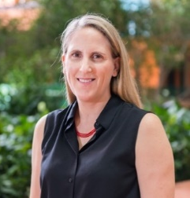
Associate Professor Alison Pettit is Director of the Biomedical Research at Mater Research Institute-UQ and an ARC Future Fellow leading the Bones and Immunology Research Group. She has led biological discoveries in macrophage participation in bone and bone marrow biology and translated her understanding of how these cells detect and destroy pathogens to better understand bone repair, bone disease, cancer metastasis in bone, and haematopoietic (blood cell) stem cell transplantation. She has more than 65 original scientific publications and has won numerous awards. Allison has provided outstanding leadership and mentoring including development of a grant scheme to encourage strong performing female researchers and fellowship schemes for early and mid-career researchers. She is a Director of the Australian and New Zealand Bone and Mineral Research Society Council.

Life Sciences Research Award

Winner: Professor Mia Woodruff
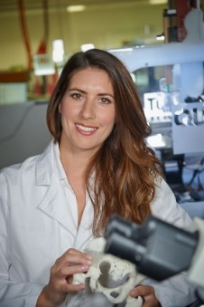
Professor Mia Woodruff is building a world-leading histology laboratory, in Brisbane, to research advanced tissue engineering. The $60m Herston Biofabrication Institute is a world first where researchers, clinicians, industry partners and students are developing 3D scanning, modelling and printing techniques to replicate human tissue. As Acting Director of the Institute, Mia has an exciting vision for a future where the fabrication of patient-specific replacement tissue and organs is safe, cost-effective and routine. Mia completed her PhD in 2006 and was promoted to Professor in 2017. She has published over 70 papers and is clinical lead on more than $4 million in research grants. Mia was highly commended in the Life Sciences “Rising Star” category of the 2012 WiT awards.

Entrepreneurial Startup Award

Winner: Alex Moss, of Fortitude Valley

At 25, Alex Moss has drawn on her international career in art, fashion and design to stake a claim in the multi-billion dollar medical device market. Entirely self-taught, she burst onto the technology scene after winning a NASA Global Award producing proof of concept for her Canaria earpiece in just 48 hours. The real-time medical-grade wearable device, powered by machine learning and inspired by high fashion, predicts cognitive fatigue. Now, as CEO of Canaria Technologies, Alex has attracted technical and financial support to commercialise the earpiece for the mining, oil and gas and aerospace industries.

Entrepreneurial Startup Award
Highly Commended: Simone Joyce, of Ashgrove

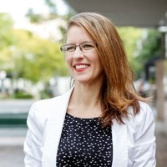
Simone Joyce’s passion for digital payments and payments technology is driving change across Australia’s banking sector, with the promise of reduced fees and a new standard of service for consumers. Her innovative payment system, which streamlines the direct debit process, has attracted substantial investor interest providing a firm foundation for the company she founded just two years ago. Direct debit is a growing sector of the payments landscape and one where service levels haven’t changed in almost 20 years.

Entrepreneurial Established Award

Highly Commended: Katie Richards, of New Farm
Katie Richards founded Australian online law firm, Virtual Legal, in 2013. She has demonstrated courage and tenacity to rebuild her business after an explosion left her with serious health issues. Virtual Legal has continued to grow with operations in New Zealand and the UK. Katie is currently launching a world first self-service legal advice platform for the public. The system harnesses AI, cognitive learning and mood sensing software, to bring professional services to 80% of the world’s population who cannot afford a lawyer.

Life Sciences Young Achiever Award

Winner: Naomi Paxton
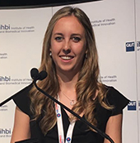
Naomi Paxton is a medical researcher currently completing her PhD at the Queensland University of Technology (QUT). She specialises in biofabrication, working at the cutting edge of science to fabricate human tissue using advanced 3D printing techniques. Naomi is a member of the Biofabrication and Tissue Morphology (BTM) Group, led by her mentor Professor Mia Woodruff. With a background in physics, Naomi has completed a Dual International Masters degree in biofabrication between QUT and the University of Würzburg, Germany. She is a passionate science communicator and STEM ambassador giving regular addresses at high school events and public showcases including two TED talks. Over the past six years, she has engaged with more than 3000 students from 40 schools across Queensland, in her role as STEM ambassador with the QUT STEM for Schools and Wonder of Science programs.

Life Sciences Young Achiever Award
Highly Commended: Jordan Debono, of Yeronga

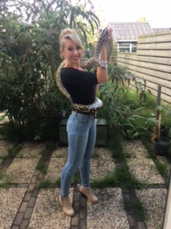
Jordan Debono has worked as a Jillaroo, RSPCA volunteer, swimming teacher, pool lifeguard. But her real fascination is with venomous snakes. She grew up in rural Northern NSW and moved to Brisbane in 2011 to study evolutionary biology under one of the world’s leading toxinologists, Associate Professor Bryan Fry. Jordan is investigating the ability for various snake venoms to affect the human blood system, and ways it can be used to create new drugs for heart disease, stroke and diabetes. She is also investigating current snake bite treatments and looking for better antivenoms and treatments for species which may not have antivenoms available.

Life Sciences Rising Star Award

Winner: Dr Felicity Davis, of West End
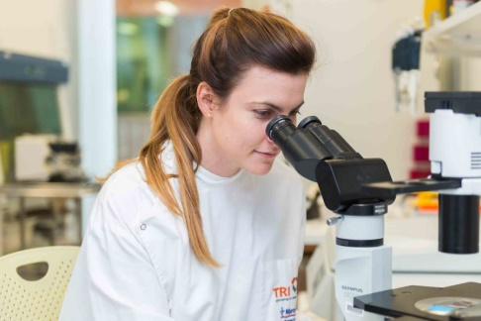
Dr Davis believes is unlocking the mysteries of breast cancer by studying breast development. Her research into the cellular hierarchy in the breast and the pathways that regulate breast stem cells and has important implications for the development of new strategies to treat and prevent breast cancer. Felicity completed her PhD in 2012, before undertaking postdoctoral research at the NIH and Cambridge University. She is a University Medalist, NHMRC-Fellow and a passionate advocate for women in science.

ICT Young Achiever Award

Winner: Yadan Luo

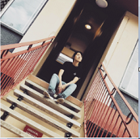
Yadan Luo is a PhD candidate in the School of Information Technology and Electrical Engineering, at the University of Queensland. Her research centres on multimedia retrieval and computer vision. She operates at the leading edge of artificial intelligence and is excited by the significant opportunities it offers to alleviate people from tedious and dangerous work. Her vision is to develop highly automated systems that can "see" and "understand" the world, saving people time and energy, and protecting them from risk, for example, by driving vehicles.

ICT Rising Star Award

Winner: Erin van der Veer, Enoggera

Erin van der Veer is a digital transformation specialist in the Department of Transport and Main Roads (TMR). Erin joined TMR as a procurement graduate in 2010 and, over the past eight years, has been involved in some of the department’s biggest IT projects. In 2016 Erin was a foundation member of the Digital Program, first in the role of Manager (Digital Maturity) and in 2017 moved into the newly created role of Manager (Digital Capability), leading the department’s digital transformation. She is currently developing an internal digital capability development network with a longer-term view of establishing a ‘AirTasker’-style network for TMR, where individuals and teams connect and work together based on their expertise and interests.

ICT Professional Award

Winner: Amanda Miotto, Brisbane
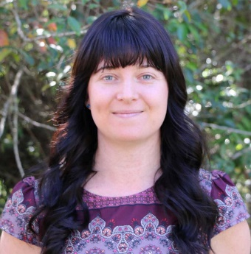
Amanda Miotto is an eResearch Senior Analyst and Software Developer for Griffith University. For the past ten years she has helped researchers achieve and accelerate their outcomes using technology. As lead organiser for the Research Bazaar Brisbane conference, she has been actively involved in training hundreds of researchers in data science. This has built up the technical skillset of our researchers across all of Queensland. We are very proud as this year, 62% of our 257 attendees identified as female, 69 stated English was not their first language, 36 attendees were Primary Caregivers and 32 were the first generation to receive tertiary education.

Employer of Choice Award Corporate

Winner: PwC
PWC Queensland is leading the way in the development of a diverse and family-friendly workplace with significnt programs in place to enourage gender equity and diversity. The organisation is part of a renowned network of firms operating in 157 countries with 223,000 people delivering quality in assurance, advisory and tax services. As a leading people business, diversity and inclusion are critical to PwC Australia’s vision, values and strategy.

Employer of Choice Award Corporate

Highly Commended: Super Retail Group

Home to retail brands like BCF, Rays, Rebel, Supercheap Auto and Super Retail Commercial, the Group has operations in Australia, New Zealand and China, with an active strategy to drive diversity across its 630 stores and 11,580 employees.

Employer of Choice Small Business

Winner: Virtual Legal

Virtual Legal is an online law firm based in Brisbane servicing Australia and New Zealand. The business provides property, business, family law, wills and estate planning legal services to clients without ever meeting them. It has established a new model for remote, flexible working that challenges convention in traditional legal and professional practice firms. (See founding CEO Katie Richards above).

Media contact:
Marie Howarth
Marie.howarth@wit.org.au
0412 111 962

About WiT
Women InTechnology (WiT) is Queensland’s peak body for women in the ICT and Life Science industries. Founded 21 years ago, WiT is one of the biggest and most respected technology industry associations in Australia representing more than 5000 professionals from every branch of science and ICT. The organisation works to promote the achievements and advance the status of women in industry and technology building a strong and collaborative community and provides opportunities for advancement through its Board readiness, mentoring and other professional development and networking programs.

